Fort Calhoun 2020 JV Football
Tekamah Herman vs. Ft. Calhoun

DIRECTOR: Andrew Christensen (402-427-3655)

DATE: Monday, September 14, 2020 6:00pm- JV Only

TEAMS ENTERED: Tekamah Herman vs. Ft. Calhoun

ENTRY FEE: None

ADMISSION Adults- $3.00 / Students- $2.00

GAME TIME: JV @ 6:00pm

HALF-TIME 15 Minutes

PARKING Drop off at South entry gate and head north to visitor locker room. An administrator will be there to greet you. Buses park in northwest corner of south parking lot. Pictured below.

CONCESSIONS Only bottled/canned drinks and prepackaged candy will be sold. Mask are required in the concessions area that is roped off.

SEATING Please advise parents & fans to bring bag chairs/blankets. Seating will be limited. 5 sets of bleachers were brought in but will only accommodate 80-100 spectators if there is not social distancing. With social distancing, bleachers will only hold 40-50 spectators. Spectators are welcome to walk the track and find a seat in a bag chair along the flagged area.

WATER Please bring your own water bottles and jugs. We can provide water if needed, but it will be helpful if your team brings your own water coolers prepared and ready.

TEAM LOCATION The visiting team will be on the east side of the field. Press box location is the far north box. Endzone camera should be placed behind the north side goal post. Locker rooms are in the north building, north of the football field. Visiting teams have their own building and space.

NSAA RULES There are multiple changes to the rules and regulations in Football. Please be sure to look over rules changes so we can adhere to them and keep the games moving along. This will be monitored by the officials

OFFICIALS

COVID CHANGES Listed below.

Pioneer Football
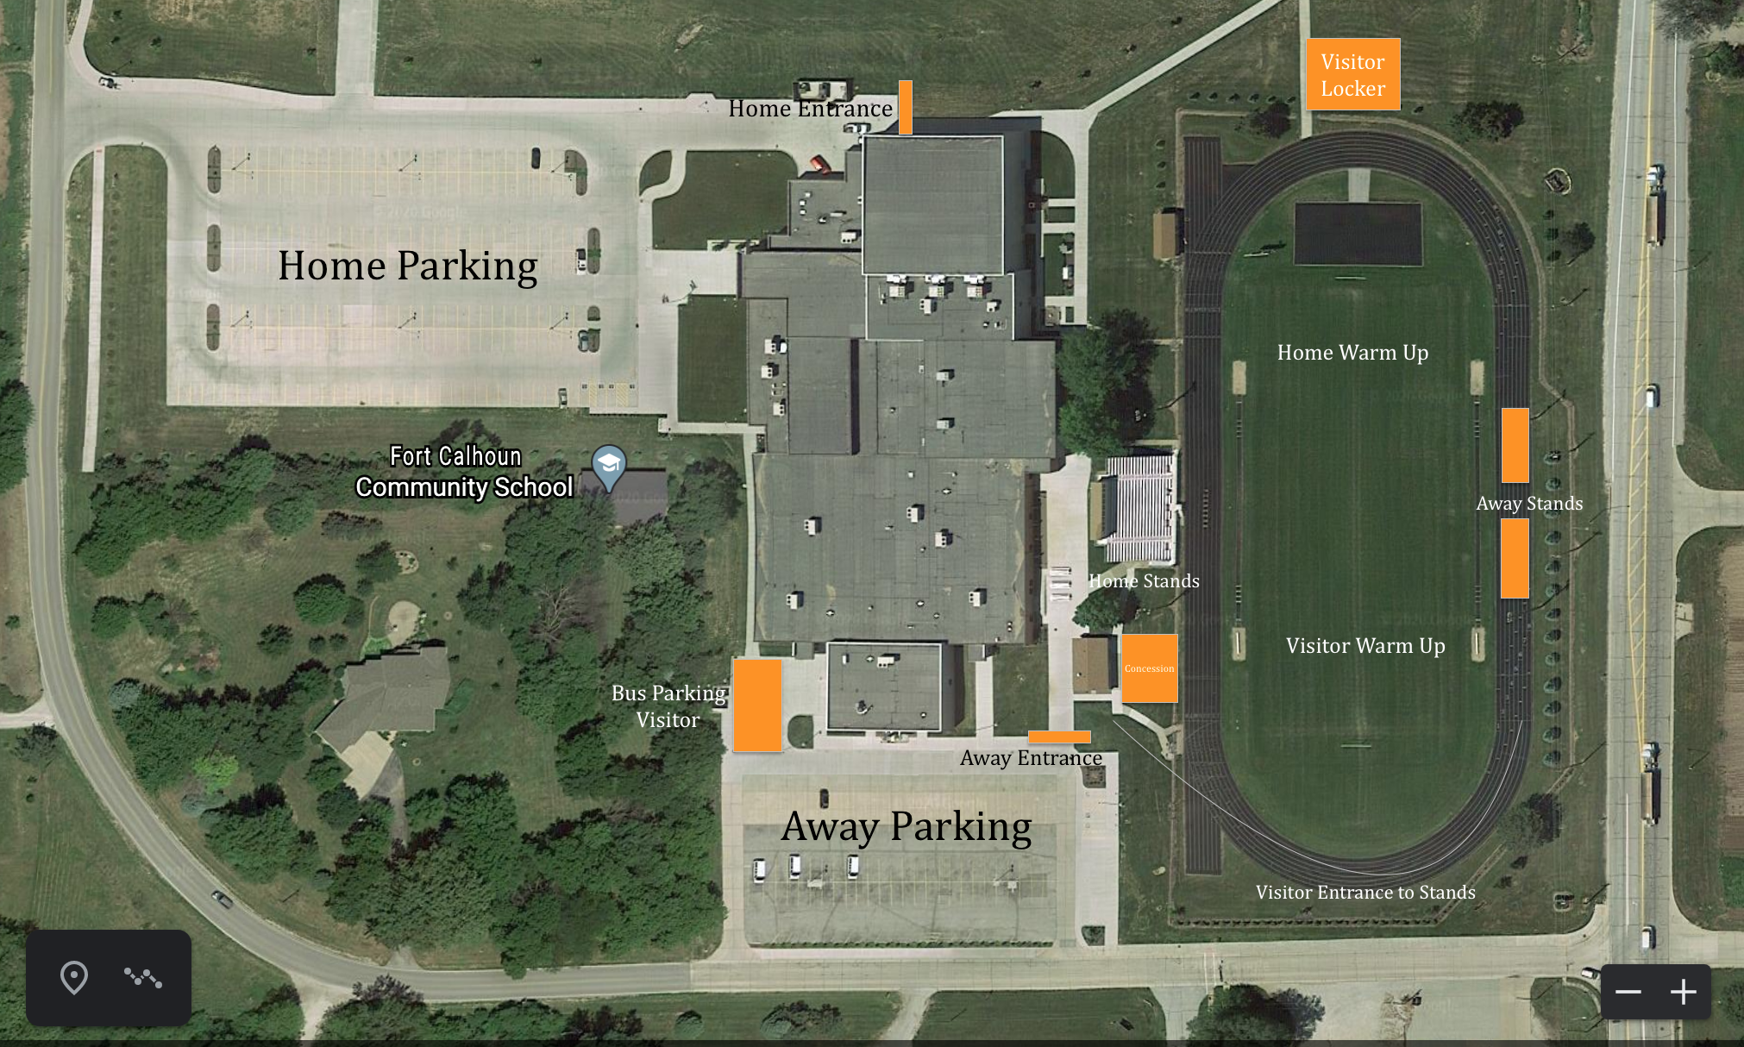

- Fort Calhoun Schools:
  - At Fort Calhoun Community Schools, it is our goal to keep communities and athletes separated at events. Please use social distancing. Communities and fans will have no contact with athletes and coaches during the competition. It is our focus to keep our athletes, coaches, and community members as safe as possible at our events.
- Attendance Restrictions
  - No attendance restrictions for JV and Junior High games.
- Entrance
  - Home Spectators- Northwest parking lot and north gate entrance ONLY.
  - Visitor Spectators- South parking lot and south gate entrance ONLY.
- Home and Away Stands
  - Visitor bleachers on the east side of the field will be provided to separate communities and promote social distancing.
  - Visiting spectators will walk along the south side of the track to get to bleachers on the east side of the field.
  - Bleachers will only hold 80-100 spectators.
  - Away Spectators- Be prepared to bring bag chairs, as there will not be a lot of bleacher space. Standing room on the track is an option, but seats are limited. Fort Calhoun apologizes for the inconvenience.
- Masks
  - Required to enter the facilities, concession stand area, and restrooms
  - Once in the facility, masks are encouraged along with social distancing, but masks are no longer required.
  - Masks will be highly recommend in the stands
- Concession Stands
  - Mask required
  - A mask required area will be roped off. Once in the roped off area, masks will be required.
- Restrooms
  - Football Field Restrooms (Concessions area)
  - Masks required to use the restroom facilities
- Gate
  - Masks are mandatory
  - Admission
    - Adult- $3.00
    - Student- $2.00
    - 4 Years and Under- Free
- Stream Live- FC Live
  - https://www.nfhsnetwork.com/schools/fort-calhoun-high-school-fort-calhoun-ne

